**EX:No.1**   **221501015**

**21/01/25**

**Program to implement time series data for import library, load data, Pre-processing and visualising**

**Aim :**

To implement time series data for importing, loading, preprocessing, and visualising data.

**Implementation :**

import pandas as pd

import numpy as np

import matplotlib.pyplot as plt

**Loading the dataset**

file_path = 'BTC-2020min.csv'

data = pd.read_csv(file_path)

**Cleaning the datase**t

# Convert 'date' to a datetime object

data['date'] = pd.to_datetime(data['date'], errors='coerce')

# Drop rows with invalid or missing dates

data = data.dropna(subset=['date'])

**Preprocessing the dataset**

# Remove duplicate entries based on the 'date' column

data.drop_duplicates(subset=['date'], keep='last', inplace=True)

# Set 'date' as the index

data.set_index('date', inplace=True)

# Sort the data by date

data.sort_index(inplace=True)

Save the cleaned data for future use

data.to_csv('cleaned_BTC_data.csv')

print("Data loading, cleaning, and preprocessing completed.")

**Visualizing the dataset**

plt.figure(figsize=(10, 6))

plt.plot(data['close'], label='BTC Close Price', color='b', linewidth=1.5)

plt.title('Bitcoin Close Price Over Time', fontsize=16)

plt.xlabel('Date', fontsize=12)

plt.ylabel('Price in USD', fontsize=12)

plt.grid(True, linestyle='--', alpha=0.6)

plt.legend()

plt.show()

**Output :**

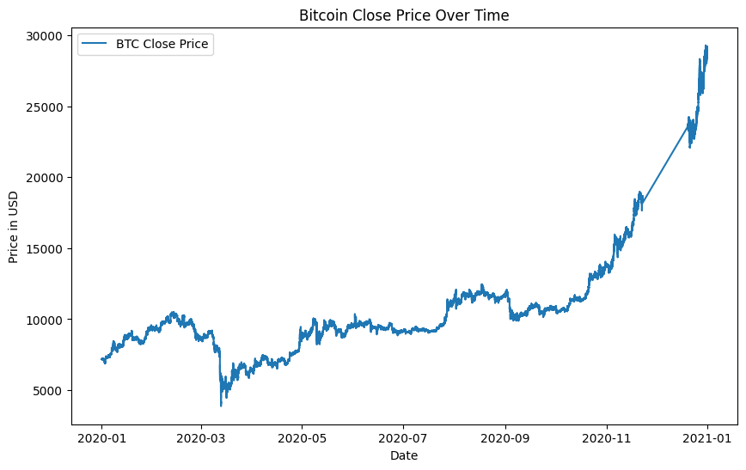

**Result:**

Thus importing, loading, pre-processing, and visualising time series data has been successful.